Name __________________________________ Date ____________________________

**Test Date: Thursday, October 27th**

Science – Study Guide Stars, Constellations, & Planets

**Know these vocabulary words: (Use your Science Interactive Notebook/textbook/handouts)**

**Vocabulary:**

Rotate axis revolve orbit

Moon phase solar system planet

Star sun (made mostly of?) constellation galaxy

1. What causes day and night (sunrise and sunset) on Earth?
2. Name 5 major constellations. (p.89 in textbook)
3. Stars: What are they made of?_____________________________________________

What does the color tell you?_______________________________________________

Why does their position seem to change as seasons change? ______________________

_______________________________________________________________________

How are stars different from planets? _________________________________________

_______________________________________________________________________

1. Planets: What are the planets in order from the sun? ___________________________

________________________________________________________________________

1. How can you tell a planet from a star in the night sky? ___________________________

________________________________________________________________________

1. Why do stars seem to twinkle? ________________________________________________________________________

________________________________________________________________________

1. What galaxy is our solar system in? What type is it? _____________________________
2. Compare how a planet rotates with how it revolves. ____________________________

________________________________________________________________________

1. How does a planet’s orbit compare to its distance from the sun? to the length of its

year? __________________________________________________________________

________________________________________________________________________

1. What objects in space above Earth take pictures of stars and planets? _____________

______________________________________________________________________

1. What causes seasonal changes
2. Name all of the phases of the moon.

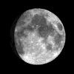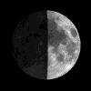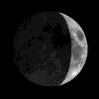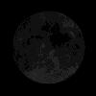

_____________ ______________ ______________ ______________

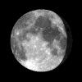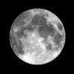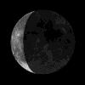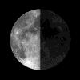

______________ ______________ ______________ _____________

How long does it take for a new moon to change to a first quarter moon? _________________

How long does it take for a first quarter moon to change to a full moon? _________________

How long does it take for a full moon to change to a third quarter moon? _________________

How long does it take for a third quarter moon to change to a new moon? ________________

1. What causes the moon to have different phases? ______________________________

________________________________________________________________________

________________________________________________________________________